## TRADITIONAL TRIBUTE – CASKET PRESENT

# **Professional Services**

# Arrangement Consultation $1145.00

# (Includes service staffing requirement)

Completing Documents $200.00

Care of Deceased $395.00**

(Includes embalming, dressing, casketing and any cosmetology required)

# Initial Transfer of Deceased $420.00**\***

Visitation $295.00

# Funeral Coach $350.00

# Facilities $205.00

### **Total Professional Fee: $3010.00**

Consumer Protection Authority Fee: $ 40.00

**Death Certificate (GST exempt): $ 27.00**

**\*\*If deceased has been autopsied $650.00**

## GRAVESIDE TRIBUTE (WITHOUT VIEWING)

**Professional Services**

Arrangement Consultation $995.00

# (Includes service staffing requirement)

Completing Documents $200.00

# Initial Transfer of Deceased $420.00**\***

Care of Deceased $125.00

(includes bathing & dressing)

Funeral Coach $350.00

# Facilities $205.00

### **Total Professional Fee: $2295.00**

Consumer Protection Authority Fee: $ 40.00

**Death Certificate (GST exempt): $ 27.00**

**\*If transfer is required from home, hospice or care facility an extra charge of $100 will apply.**

**EAST OF Chilliwack additional transfer charges will apply.**

## MEMORIAL TRIBUTE – NO CASKET PRESENT

**Professional Services**

Arrangement Consultation $995.00

# (Includes service staffing requirement)

Completing Documents $200.00

Initial Transfer of Deceased $420.00**\***

# Facilities $205.00

### **Total Professional Fee: $1820.00**

**Cremation Fee: $ 450.00**

**Basic Cremation Container $ 95.00**

**Consumer Protection Authority Fee: $ 40.00**

**Death Certificate (GST exempt): $ 27.00**

## SIMPLE DISPOSITION (NO TRIBUTE)

**Professional Services**

Arrangement Consultation $290.00

Initial Transfer of Deceased $420.00**\***

# Facilities $ 60.00

## Total Professional Fee: $770.00

**Basic Cremation Container $ 95.00**

**Cremation Fee: $450.00**

**Consumer Protection Authority Fee: $ 40.00**

**Death Certificate (GST exempt): $ 27.00**

**GST: $ 67.75**

**TOTAL COST: $1449.75**

**\*If transfer is required from home, hospice or care facility an extra charge of $100 will apply.**

**EAST OF Chilliwack additional transfer charges will apply.**

**OTHER SERVICE CONSIDERATIONS**

Basic Sanitary Care $125.00

Basic Sanitary Care (autopsy) $250.00

Fun. Dir. Statement of Death $ 10.00

Viewing Facility $295.00

Cremation Fee $450.00

Witness Cremation Additional $450.00

Rush Cremation Additional $150.00

Weekend Viewing Surcharge $350.00

Weekend Service Surcharge $500.00

Caskets Variable

Rental Casket (incl. insert) $895.00

Full Size Urns From $155.00

Keepsake Urns From $ 65.00

Keepsake Jewelry From $104.00

Fingerprint Jewelry From $159.00

Memorial Guest Book $ 55.00

Memorial Service Folders $ 1.25 each

**URN INTERMENT – GRAVESIDE SERVICE**

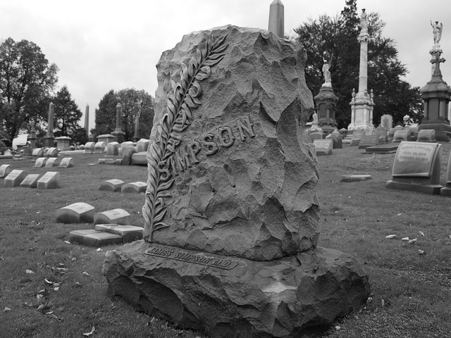Staff will bring urn to cemetery, attend service,

provide 6 chairs, podium, microphone & speaker

and umbrellas. $300.00

We are independently owned and operated and have our own crematory on our premises. Our independent family ownership makes us accountable to the families we assist and responsible for services we provide. Proudly, we provide straight talk, ethical service with affordable fees.

We provide all the same services that are provided by other funeral homes; from a Simple Cremation to a Memorial Tribute or a Graveside Tribute or a full Traditional Funeral Tribute with viewing and burial. Our funeral home does not have a chapel on premise. Funeral or memorial services can be held in your church, or a church that we arrange for you or a non-denominational venue. Memorial tributes may also be held in your home, your apartment or condominium common room or clubhouse, a community hall, as well as many restaurants and golf and country clubs. Most offer convenient reception facilities at less than the cost at most funeral homes.

By designing our facility without a chapel we are able to keep our expenses lower. Lower overhead expenses enable us to provide more affordable services for you. Our fee structure is designed so that you only pay for services that you have requested. We don’t factor in fees for items or services you don’t need or use.

We can conduct our initial arrangement conference in the security and comfort of your own home, usually around your kitchen or dining room table, or you can come to us. Home arrangements give you the security of making difficult decisions in your own comfortable environment and alleviates the need for you to visit a funeral home and the commercial pressures found within them.

Our goal is to provide our services the old fashioned way. “To serve others as we ourselves would like to be served” and to provide affordable, professional service without compromising the dignity of the deceased or the dignity of those left behind.

C:\Users\Windows User\AppData\Local\Microsoft\Windows\Temporary Internet Files\Content.IE5\UE5LXFZV\MC900026833[1].wmf

Wiebe & Jeske Burial and Cremation Care Providers Ltd. is registered as a

Full Service Provider pursuant to the Cremation, Interment and Funeral Service Act with

Consumer Protection BC.

**Wiebe & Jeske**

**202 – 31314 Peardonville Road**

**Abbotsford, BC V2T 6K8**



“Serving others as we ourselves

would like to be served.”

To Contact Us:

[www.wiebeandjeskefh.com](http://www.wiebeandjeskefh.com)

[wjbccp@telus.net](mailto:wjbccp@telus.net)

Abbotsford Area

604.859.5885

Metro Vancouver Area 604.857.0711

Chilliwack Area

604.824.1324